Fall 2021 Career Services Report

Table of Contents

Overall Summary

First Destination Survey

Class of 2021

Fall 2021 Statistics:

November

Week 1

Week 2

Week 3-4

December

Week 1

Week 2

Week 3

Big Interview Interactions

People Grove Interactions

Campus Labs Reports

2021 Virtual Tech, Cybersecurity, Computer and Data Science Micro-Fair

2021 Virtual Accounting and Finance Career Fair

Events, Appointments, Job Postings

September

October

November

December

# First Destination Survey 2021

**Overall:**

There were a total of 2,149 graduates in the Class of 2021. As of December 15, 2021, there are 1,876 respondents (87.6% of FDS recipients have responded). This is an increase from 2020 where only 81.5% of students responded, however this is still a decrease from 2017-2019 (pre-pandemic) where the knowledge rate averaged at 92%.

Changes have been overall positive: More students are employed or continuing education in 2021 than in 2020; while the number of students who are still looking for employment or are not looking for employment has decreased substantially. Volunteer and military work have remained steady at 16 respondents for volunteer work and 12 respondents for military work respectively.

**Note that the average percentage change for employed students per week is 1.86%. 1.78% for those in continuing education and -3.64% for those still seeking employment.** This means that the amount of students getting employed or enrolling into graduate school after graduation increases every week while the amount of unemployed students decreases every week, and at a faster rate.

These graphs showcase Year-To-Year comparisons for the final two months of FDS surveys from the years 2017-2021.

November: Year to Year Comparisons

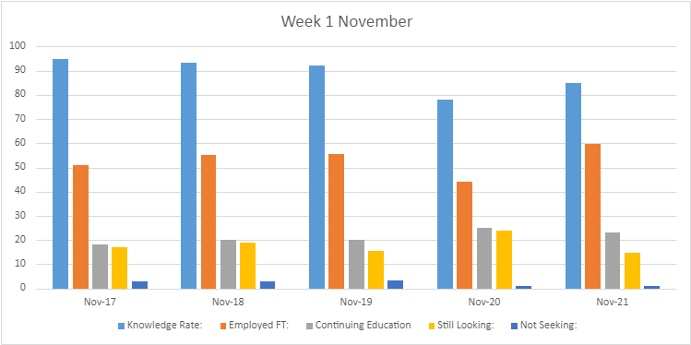

**Week 1: Year to Year Comparisons**

|  |  |  |  |  |  |
| --- | --- | --- | --- | --- | --- |
| **Date** | **11/20/17** | **11/08/18** | **11/08/19** | **11/05/20** | **11/04/21** |
| Knowledge Rate | 94.7% | 93.4% | 92% | 77.9% | 85% |

|  |  |  |  |  |  |
| --- | --- | --- | --- | --- | --- |
| **Date** | **11/20/17** | **11/01/18** | **11/08/19** | **11/05/20** | **11/04/21** |
| Employed FT | 51% | 55% | 55.4% | 44% | 59.57% |
| Continuing Education | 18% | 20% | 20% | 25% | 22.92% |
| Still seeking | 17% | 19% | 15.6% | 24% | 14.9% |
| Not seeking | 3% | 3% | 3.4% | 1% | 0.9% |

As of **11/4/2021**, our first destination outcomes are **85%** knowledge rate, **60%** secured full time employment, **23%** continuing education and **15%** seeking employment.

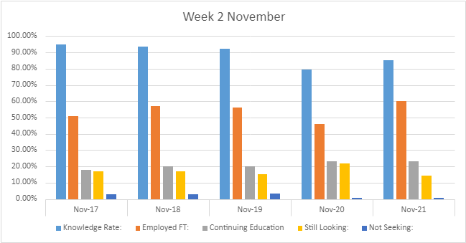

**Week 2: Year to Year Comparisons**

|  |  |  |  |  |  |
| --- | --- | --- | --- | --- | --- |
| **Date** | **11/20/17** | **11/15/18** | **11/14/19** | **11/11/20** | **11/11/21** |
| Knowledge Rate | 94.7% | 93.6% | 92.1% | 79.6% | 85.10% |
| Employed FT | 51% | 57% | 56% | 46% | 60% |
| Continuing Education | 18% | 20% | 20% | 23% | 23% |
| Still Seeking | 17% | 17% | 15.1% | 22% | 14.23% |
| Not Seeking | 3% | 3% | 3.4% | 0.8% | 0.9% |

As of **11/11/2021,** our first destination outcomes are **60%** knowledge rate, **46%** secured full time employment, **23%** continuing education, **0.9%** not seeking, and **14.23%** seeking employment.

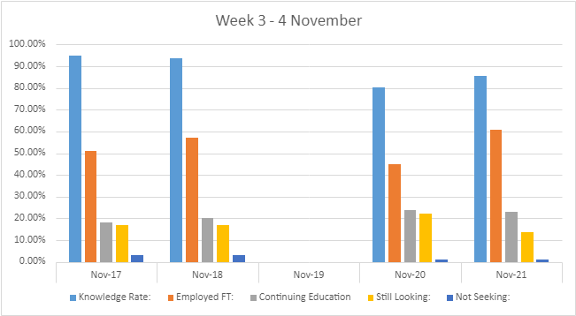

**Week 3-4: Year to Year Comparisons**

|  |  |  |  |  |  |
| --- | --- | --- | --- | --- | --- |
| **Date** | **11/20/17** | **11/20/18** | **11/21/19** | **11/20/20** | **11/18/21** |
| Knowledge Rate | 94.7% | 93.6% | N/A | 80.2% | 85.7% |

|  |  |  |  |  |  |
| --- | --- | --- | --- | --- | --- |
| **Date** | **11/20/17** | **11/15/18** | **11/21/19** | **11/20/20** | **11/18/21** |
| Employed FT | 51% | 57% | N/A | 45% | 61% |
| Continuing Education | 18% | 20% | N/A | 24% | 23% |
| Still seeking | 17% | 17% | N/A | 22% | 14% |
| Not seeking | 3% | 3% | N/A | 1% | 0.92% |

As of **11/18/21**, our FDS outcomes are **85.7%** knowledge rate, **61%** secured full-time employment, **23%** continuing education, **0.92%** not seeking, and **14%** still seeking employment.

Key indicators including knowledge rate and those still seeking employment have visibly improved from 2020, and even in 2018. This improvement is also shown from the lower percentage of people not seeking employment as well. The lower rate of those “still seeking” or “not seeking” is from lower knowledge rate from 2020 to 2021.

*Note: Week 4 of November 2019 is missing data

December: Year to Year Comparisons

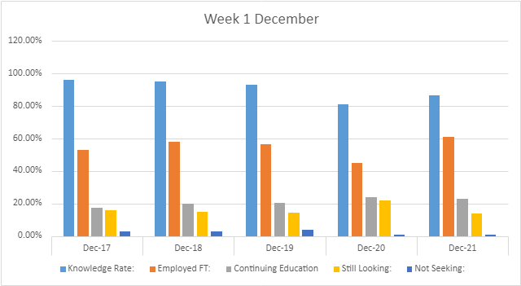

**Week 1: Year to Year Comparisons**

|  |  |  |  |  |  |
| --- | --- | --- | --- | --- | --- |
| **Date** | **12/01/17** | **12/06/18** | **12/04/19** | **12/03/20** | **12/02/21** |
| Knowledge Rate | 96.3% | 95% | 93% | 81.3% | 86.7% |
| Employed FT | 52.9% | 58% | 56.47% | 45% | 61% |
| Continuing Education | 17.3% | 20% | 20.4% | 24% | 23% |
| Still Seeking | 16% | 15% | 14.4% | 21.9% | 14% |
| Not Seeking | 3% | 3% | 3.6% | 0.8% | 0.92% |

Note: Metrics are more positive than in 2020, but it still trails behind pre-pandemic years. Knowledge rate still hovers around 86%. Students are not responding as much as they used to. Full-time employment is on the recovery at 61%. We will see if this trend continues through the next year. “Continuing education” and “Still Seeking” remain about the same. Those not seeking employment have also remained the same since 2020, but there is a noticeable decrease in alumni not seeking employment after 2020. It is likely that 2021 alumni have a gap in FDS responses.

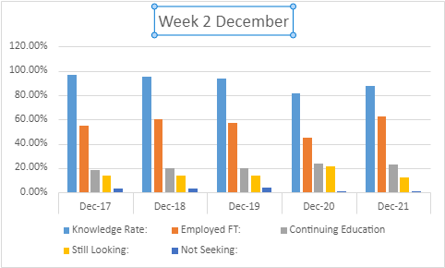

**Week 2: Year to Year Comparisons**

|  |  |  |  |  |  |
| --- | --- | --- | --- | --- | --- |
| **Date** | **12/17/17** | **12/13/18** | **12/12/19** | **12/11/20** | **12/09/21** |
| Knowledge Rate | 96.7% | 95.2% | 94% | 81.4% | 87.3% |
| Employed FT | 55% | 60% | 57% | 45% | 62.21% |
| Continuing Education | 18% | 20% | 20% | 24% | 22.81% |
| Still Seeking | 14% | 14% | 14% | 21% | 12.37% |
| Not Seeking | 3% | 3% | 4% | 1% | 1.12% |

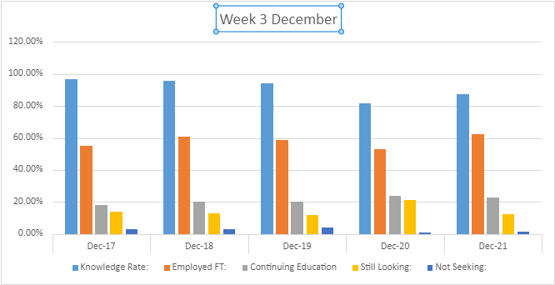

**Week 3: Year to Year Comparisons**

|  |  |  |  |  |  |
| --- | --- | --- | --- | --- | --- |
| **Date** | **12/17/17** | **12/19/18** | **12/19/19** | **12/17/20** | **12/15/21** |
| Knowledge Rate | 96.7% | 95.8% | 94% | 81.5% | 87.3% |
| Employed FT | 55% | 61% | 58.5% | 53% | 62.31% |
| Continuing Education | 18% | 20% | 20% | 24% | 22.81% |
| Still Seeking | 14% | 13% | 12% | 21% | 12.26% |
| Not Seeking | 3% | 3% | 4% | 1% | 1.12% |

# Big Interview

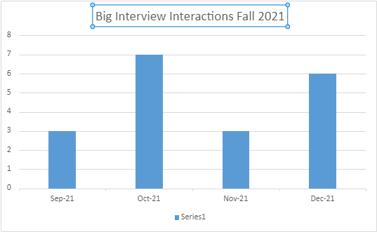

|  |  |  |  |  |
| --- | --- | --- | --- | --- |
| **Month** | September | October | November | December |
| Number of Big Interview Interactions | 3 | 7 | 3 | 6 |

Number of Big Interview Interactions decreased in Fall 2021 compared to Spring 2021 and Fall 2020. There were 3 Big Interview Interactions in September, 7 Big Interview Interactions in October, 3 Big Interview Interactions in November, and 6 Big Interview Interactions in December.

Total: 19

# Fordham Mentorship Network PeopleGrove Interactions

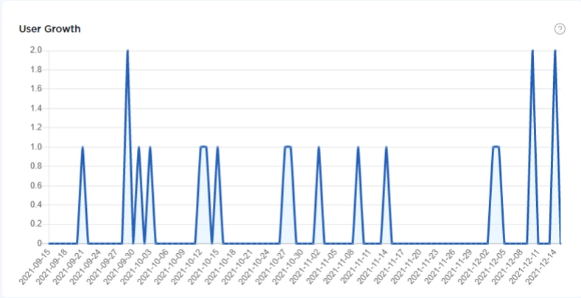

**Fordham Mentorship Network (PeopleGrove Interactions)**

Totals:

|  |  |  |  |  |
| --- | --- | --- | --- | --- |
| August | September | October | November | December |
| 1,716 | 1,906 | 2,092 | 2,113 | 2,120 |

**Changes through each month by number and percentage:**

|  |  |  |  |
| --- | --- | --- | --- |
| **August - September** | **September - October** | **October - November** | **November - December** |
| * **190** | * **186** | * **21** | * **7** |
| * **11%** | * **9.7%** | * **1%** | * **0.03%** |

**August**

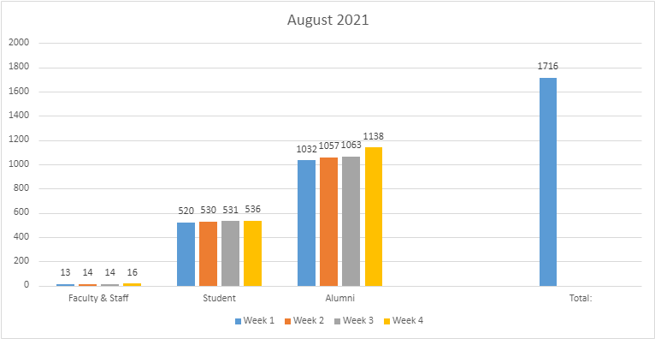

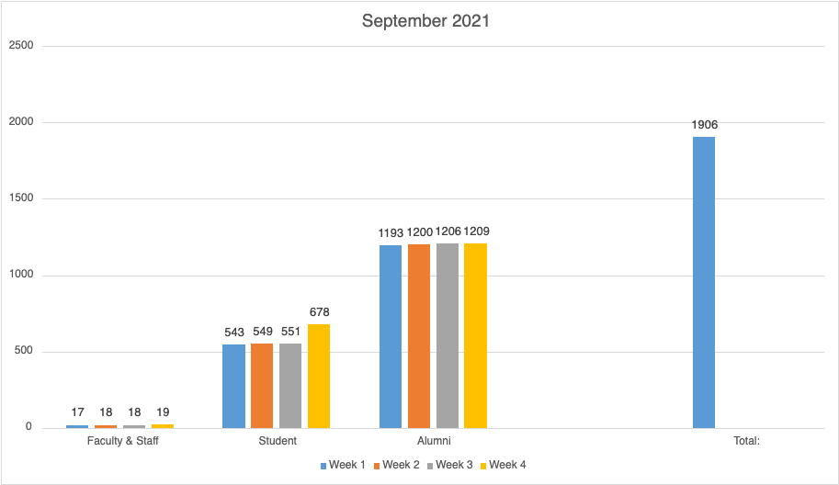

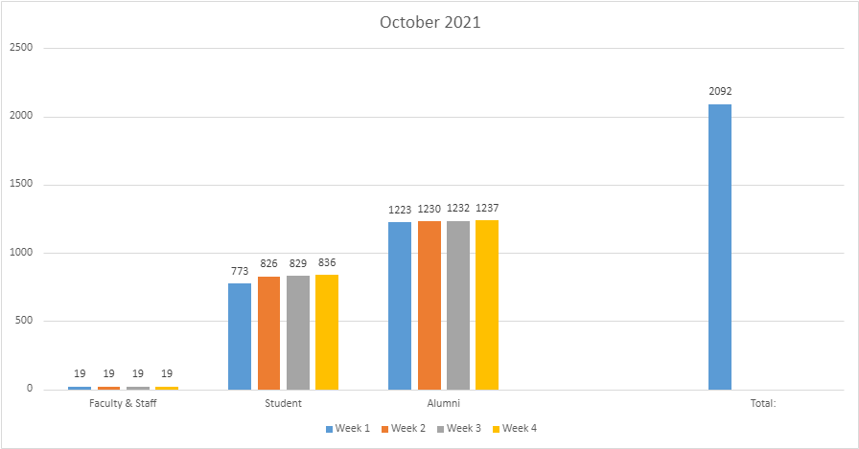

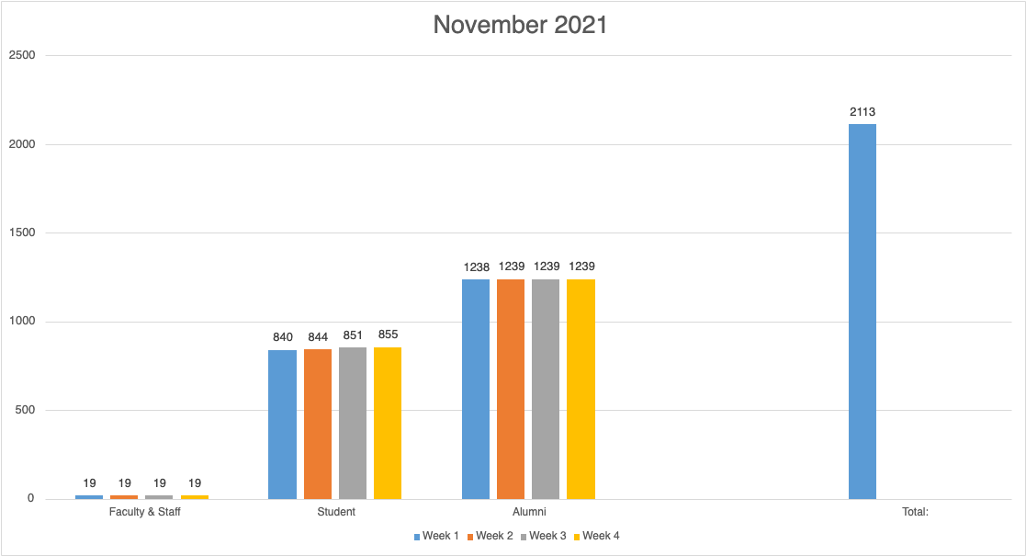

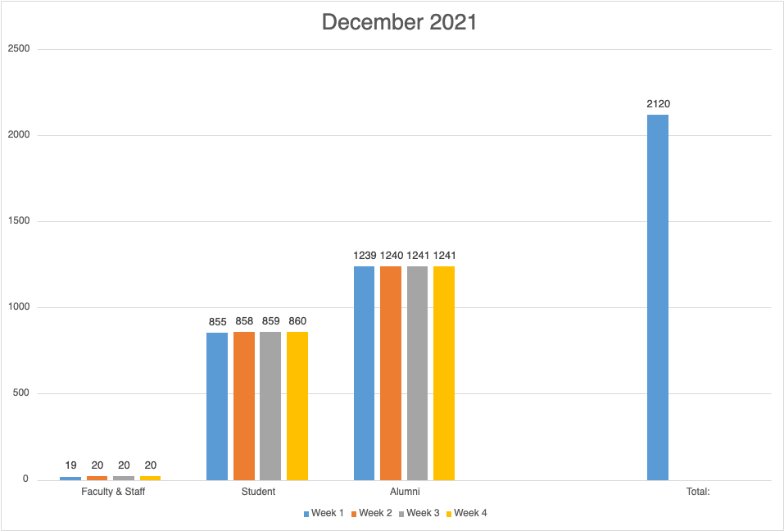

**Campus Labs Reports**

**Fall 2021 Tech, Cybersecurity, Computer & Data Science:**

**Student Campus Labs Report**

The Fall ‘21 Tech, Cybersecurity, Computer, and Data Science fair was held virtually via Handshake. **The Campus Labs student survey for the fair consisted of responses from 2 students, which represents a relatively small sample size, despite multiple follow-up reminder emails following the fair to 99 total student attendees.** Nonetheless, the data provided suggests a few findings with practical implications that stimulate further exploration of the fair’s success and future implementations.

Both of the 2 student respondents *strongly agreed* about their confidence in presenting themselves virtually, while both *moderately agreed* about their confidence in the quality of their resume. The two respondents were split between *moderately* and *strongly agree* for their 30-second pitch/self-introduction, and finally both surveyed students *moderately agreed* about their confidence in their knowledge of companies/organizations. Thus, both respondents seemed moderately to strongly confident in the various factors pertaining to their performance or experience at the fair, with “presenting myself virtually” and 30-second pitch being the highest rated, and quality of resume and more so, knowledge of companies, falling slightly lower. These findings seem to somewhat agree with the surveyed employers’ responses, as they rated students highest on quality of professional appearance (100%), followed by quality of resume, 30-second-pitch, and knowledge of organization (88.24%, 57.89%, and 44.44% respectively.) From this combined data, we gather that the largest factor students can improve upon in order to boost both their impressions on employers and self-confidence levels is their ability to perform proper research of attending companies/organizations.

In order to address this concern, we plan to increase marketing strategies in advance of the fair pertaining to how to best research companies, such as through Handshake, LinkedIn, and companies’ websites. This can be achieved through giving this area greater emphasis in prep sessions and pre-fair counseling appointments, as well as marketing initiatives like shared career fair tips. Finally, as one student respondent rated the virtual fair average, while the other rated it excellent, yet both agreed that they would recommend the fair to others, the fair can be deemed an overall success for students, with the opportunity to expand preparation efforts and programming around the importance of gaining knowledge of companies of interest, in particular.

**Division of Student Affairs & Athletics**

**Office of Career Services**

**2021 Virtual Tech, Cybersecurity, Computer and Data Science Micro-Fair**

**September 16, 2021**

**Employer Report**

**Learning Goal**

The goal of the Student Voice survey of employers who attended the Virtual Tech, Cybersecurity, Computer, and Data Science Micro-Fairon Thursday, September 16, 2021, was to gauge overall satisfaction and use this information to further improve this and other events hosted by the Office of Career Services.

**Assessment Method**

The survey was distributed on the day of the event with the request for it to be completed and turned in upon the completion of the event. There were a total of 7 employers who responded to the survey compared to 20 in Fall 2019 and 19 in Fall 2018, out of a total of 21 employers who attended the fair compared to 25 in Fall 2019 and 26 in Fall 2018.

**Assessment Results**

The survey yielded a response rate of 100% ( 80% F’19; 73% F’18). Limitations are typical of all Student Voice surveys as are with any survey that requests self-directed responses. Employers do not have equal levels of experience or exposure to other institutions, so their responses when comparing our students with others may not be completely accurate.

* 100% (100% F’19; 100% F’18) of the employers who responded stated that they would attend a Career Fair hosted by Fordham University in the future
* 85.75% (95% F’19; 81.25% F’18) of respondents said they were moderately or very likely to work with students whom they met at this event - This is a 10% decrease from 2019, but a 4% increase from 2018.

Rating the overall impression employers had of our students when compared to others (from above average to excellent):

|  |  |  |  |  |  |  |
| --- | --- | --- | --- | --- | --- | --- |
| Year | Resume Quality | Professional Appearance (Virtual Only) | 30-second pitch | First Impression | Knowledge of organization | Asked Pertinent Questions |
| 2021 | 83.33% | 71.43% | 50% | 71.43% | 28.7% | 57.1% |
| 2019 | 88.24% | N/A | 57.89% | 75% | 44.44% | 80% |
| 2018 | 60% | N/A | 55% | 65% | 40% | 70% |

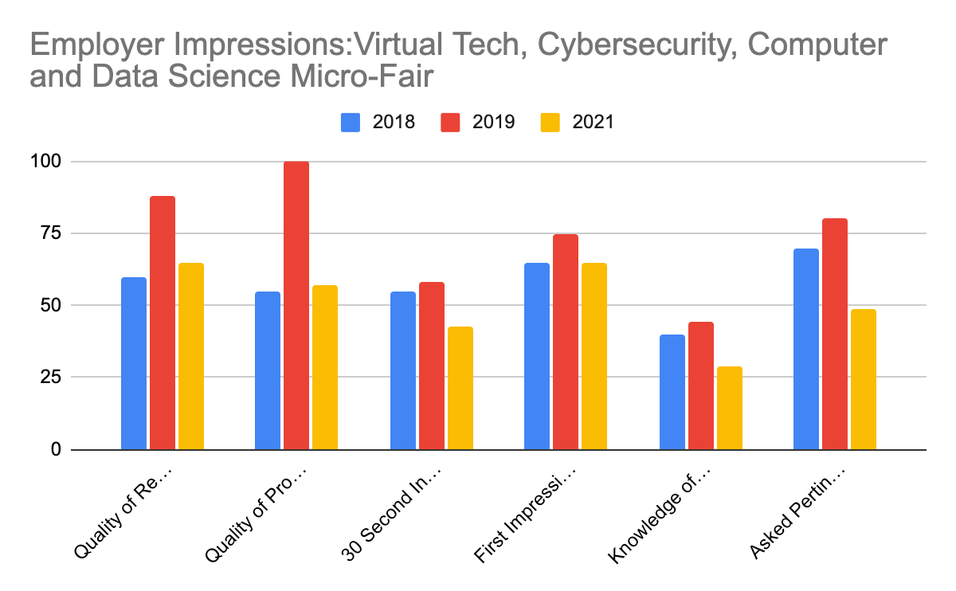

Overall, 71.43% (72.22% F’19; 50% F '18) of respondents rated Fordham students somewhat or much better in comparison to students from other schools.

**Division of Student Affairs**

**Office of Career Services**

**2021 Virtual Tech, Cybersecurity, Computer and Data Science Micro-Fair**

**September 16, 2021**

**Student Responses**

**Learning Goal**

The goal of the Student Voice survey of employers who attended the 2021 Virtual Tech, Cybersecurity, Computer and Data Science Micro-Fair on Thursday, September 16, 2021 was to gauge overall satisfaction and perceptions of the event and of our students. This event was expanded from the Accounting and Finance and Technology Fair from 2017. From student responses the expo was created to target more specific technology companies. The information collected will be used in the future to further improve this and other events hosted by the Office of Career Services.

**Assessment Method**

The survey was distributed via e-mail with 3 follow-up reminder e-mail a few days later. A total of 2 (28 F’20; 42 F’18) students responded to the survey, out of a total of 99 (129 F’19; 230 F’18) students who were surveyed.

**Assessment Results**

The survey yielded a response rate of 100% and limitations are typical of all Student Voice surveys as are with any survey that requests self-directed responses.

* 50% (39.2% F’19; 30.9% F’18) of respondents were from Fordham College at Rose Hill
* 25% (F’18) of respondents were from Fordham College at Lincoln Center; (33.3% F’18); Graduate School of Arts and Sciences 17.8% 85.7%; 17.8%  (F’18) of respondents were from the Gabelli School of Business;
* When asked primary motivation for attending the Virtual Tech, Cybersecurity, Computer and Data Science Micro-Fair (all that apply):
  + 50% (42.3% F’19; 75.6% F’18) of respondents chose ‘find an internship’; 50% (26.9% F’19; 43.2% F’18) of respondents said ‘network with employers;’ 50% (42.3% F’19; 43.2%  F’18)‘explore careers;’ 100% ( 50.0% F’19; 29.7% F’18) of respondents chose ‘find a full-time job’
* When rating their skills students strongly agreed and moderately agreed their confidence:

100% (92.3% F’19; 81% F’18) in their professional appearance (CI@95%: 5.00-5.00; SD: 0.00);  100% (80.7% F’19; F’18) in the quality of their resume (CI@95%: 4.00-4.00; SD: 0.00); 100% (65.3% F’19; 76%  F’18) in their 30-second pitch or introduction of themselves (CI@95%: 3.52-5.48; SD: 0.71); 100% (50.0% F’19; 43% F’18) in their knowledge of the companies/organizations that they approached (CI@95%: 4.00-4.00; SD: 0.00)

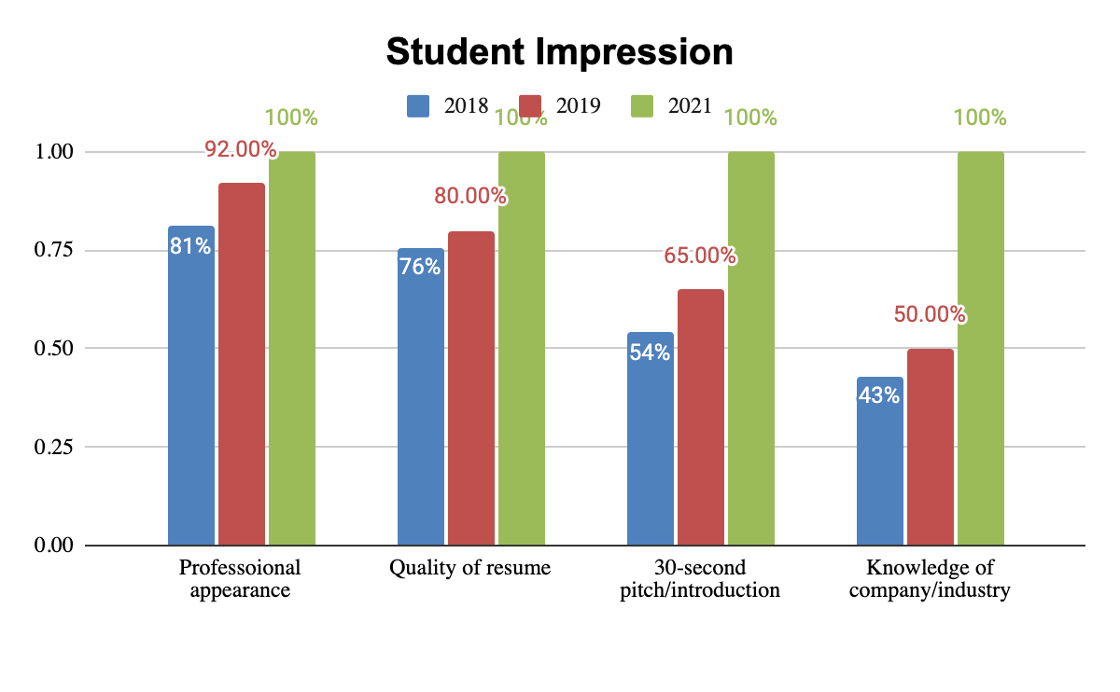

* Students were moderately to very satisfied for:
  + Types of opportunities (full-time ); 50% (CI@95%: 2.04-5.96; SD: 1.41)
  + Types of opportunities (part-time ); 50%(CI@95%: 2.04-5.96; SD: 1.41)
* When asked what services were most helpful in preparing for the Virtual Tech, Cybersecurity, Computer and Data Science Micro-Fair:
* 100% Other
* 50% Overall, respondents rated the career fair as above average or excellent, with 50% of respondents rating it as average
* When asked if respondents would recommend the Career Fair to others: 100% (86.9% F’19; 100% F’18) responded ‘yes’

**Action Taken/Planned and Results/ Future Steps**

The Fall ‘21 Tech, Cybersecurity, Computer, and Data Science fair was held virtually via Handshake. The Campus Labs student survey for the fair consisted of responses from 2 students, which represents a relatively small sample size, despite multiple follow-up reminder emails following the fair to 99 total student attendees. Nonetheless, the data provided suggests a few findings with practical implications that stimulate further exploration of the fair’s success and future implementations.

Both of the 2 student respondents strongly agreed about their confidence in presenting themselves virtually, while both moderately agreed about their confidence in the quality of their resume. The two respondents were split between moderately and strongly agree for their 30-second pitch/self-introduction, and finally both surveyed students moderately agreed about their confidence in their knowledge of companies/organizations. Thus, both respondents seemed moderately to strongly confident in the various factors pertaining to their performance or experience at the fair, with “presenting myself virtually” and 30-second pitch being the highest rated, and quality of resume and more so, knowledge of companies, falling slightly lower. These findings seem to somewhat agree with the surveyed employers’ responses, as they rated students highest on quality of professional appearance (100%), followed by quality of resume, 30-second-pitch, and knowledge of organization (88.24%, 57.89%, and 44.44% respectively.) From this combined data, we gather that the largest factor students can improve upon in order to boost both their impressions on employers and self-confidence levels is their ability to perform proper research of attending companies/organizations.

In order to address this concern, we plan to increase marketing strategies in advance of the fair pertaining to how to best research companies, such as through Handshake, LinkedIn, and companies’ websites. This can be achieved through giving this area greater emphasis in prep sessions and pre-fair counseling appointments, as well as marketing initiatives like shared career fair tips. Finally, as one student respondent rated the virtual fair average, while the other rated it excellent, yet both agreed that they would recommend the fair to others, the fair can be deemed an overall success for students, with the opportunity to expand preparation efforts and programming around the importance of gaining knowledge of companies of interest, in particular.

**Fall 2021 Accounting & Finance Fair:**

**Student Campus Labs Report**

Our career fairs continue to be virtual on Handshake due to the Pandemic regulations. Although this is the third virtual career fair and second hosted on Handshake's virtual platform, feedback suggests that students and employers experienced less technical challenges resulting in a satisfactory career fair. This success can be attributed to the Employer Relations and Student Engagement teams' partnering to provide prep-sessions and addressing potential unrehearsed technology issues. Also during the fair virtual support rooms were available for both students and employers but did not receive as much traffic compared to our initial fairs. The minor technical discrepancies and overall preparation resulted in the event’s success.

When asked to rate students across various metrics, employers rated Fordham students similarly on most impression values in comparison to 2020. Notably,“30-Second Pitch” impressions continue to decrease year over year, and are significantly lower by 14.2% compared to 2020. This decrease, while significant, does not reflect the overall positive impression students and employers had of the fair. The overall satisfaction may be due to the increased availability of workshops and attendance at resume, preparation and pre-career fair counseling sessions and appointments for the fall semester of 2021. According to the employer survey, students’ overall “first impression (87.5%)” is the same, compared to 2020. This is notable considering 1) virtual aesthetics may yield strong opinions by employers 2) a student’s digital background can be judged as part of their overall appearance and 3) handshake does not offer filtered background settings compared to other video platforms (i.e. Zoom-blurry background, Microsoft teams).

Furthermore, **when asked to rate their own abilities, surveyed students responded with a 76.6% confidence rate for their virtual presentation skills, which represents a steep decline from the 94.5% reached in 2020**. While students did tend to feel confident in their resume quality (90%), students seemed to lack confidence or personal satisfaction with their 30-second pitch (self-rated at an average of 66.6%) and their knowledge of companies/organizations with whom they interacted (also at 66.6%.) Hence, students’ lesser lack of confidence when it came to their 30-second pitch and knowledge of organizations was relatively accurately depicted by employers in their accounts.

Given this data, it is our opinion that students would benefit from greater promotion of Big Interview before upcoming fairs as an available resource to help virtually learn and practice interview skills for potential employer interactions. For example, the FCA programs at both the Rose Hill and Lincoln Center campuses can implement marketing campaigns to facilitate awareness about this practical preparation tool. Regarding ways to increase students’ awareness and research of attending employers, the Career Services team can assess the existing “career fair tips” marketing information and directly send a handout to registered students in advance of the fair with a key focus on how to identify and properly research companies of interest, perhaps including links to companies’ websites. Additionally, we noticed Midsize firms received significantly less 1:1 sign ups compared to larger firms. It is important to emphasize the value of these firms to students. To that regard, Midsize firms may need additional spotlight well in advance to the career fair for students to do their research and be intentional about the opportunity to meet with these firms. For example BKD hosted : Virtual Career Fair Prep Workshop 2 days prior to fair. 12 Students attended workshops resulting in BKD having 17/27 (1:1) sessions filled.

Overall, the career fair can be deemed a success based on employers’ high rating (87.5%) of Fordham students compared to students from other schools and 87.5% likelihood to work with students they met from the event, as well as students’ 96.4% willingness to recommend the career fair to peers. Thus, while students have a couple of professional development areas that can be further developed with greater attention and support from our team, students can realize that their backgrounds and skills are desired by employers and of overall interest and satisfaction.

**Division of Student Affairs**

**Office of Career Services**

**Student Voice Executive Summary**

**Fall 2021**

**2021 Virtual Accounting and Finance Career Fair**

**September 9, 2021**

**Employer Report**

**Learning Goal**

The goal of the Student Voice survey of employers who attended the Virtual Accounting and Finance Career Fair on Thursday, September 9, 2021 was to gauge overall satisfaction and use this information to further improve this and other events hosted by the Office of Career Services.

**Assessment Method**

The survey was distributed on the day of the event with the request for it to be completed and turned in upon the completion of the event.

|  |  |  |
| --- | --- | --- |
| Year attended | Employers Responded | Total Employers |
| 2021 | 23 (82%) | 28 |
| 2020 | 15 (25%) | 28 |
| 2019 | 22 (75%) | 29 |
| 2018 | 25 (56%) | 44 |
| 2017 | 40 (66%) | 60 |
| 2016 | 35 (64%) | 54 |

**Assessment Results**

The survey yielded a response rate of 100% (100% F’20; 75.8% F’19; 56.8% F’18; 67% F’ 17; 64.8% F’16). Limitations are typical of employer Voice surveys as are with any survey that requests self-directed responses. Employers do not have equal levels of experience or exposure to other institutions, so their responses when comparing our students with others may not be completely accurate.

* 87.5% ( 100% F’20; 95.45% F’19; 100% F’18; 92.3% F’17; 97.1% F’16) of respondents said they were moderately or very likely to work with students whom they met at this event

|  |  |
| --- | --- |
| Year | Employers likely to work with students they met at the event |
| 2021 | **87.5%** |
| 2020 | **100%** |
| 2019 | **95.45%** |
| 2018 | **100%** |
| 2017 | **92.3%** |
| 2016 | **97.1%** |

**Rating the overall impression employers had of our students when compared to others (from above average to excellent):**

|  |  |  |  |  |  |  |
| --- | --- | --- | --- | --- | --- | --- |
| Year Attended | Quality of Professional Appearance | 30-second pitch | First Impression | Knowledge of Organization | Asked Pertinent Questions | Better in comparison to other schools |
| 2021 | 85.7% | 50% | 87.5% | 28.5% | 87.5% | 87.5% |
| 2020 | 93.3% | 64.2% | 73.3% | 42.6% | 93.3% | 86.6% |
| 2019 | 90.91% | 68.18% | 77.27% | 28.57% | 68.18% | 85% |
| 2018 | 80% | 65% | 76% | 40% | 68% | 68.4% |
| 2017 | 80% | 45% | 72.5% | 18.5% | 55.5% | 56.4% |
| 2016 | 80% | 57.1% | 74.3% | 31.4% | 48.6% | 71.4% |

\***Percentage of employers who rated Fordham students overall from “above average” to “excellent” shown above**

Overall, 87.5% (86.6% F’20; 85% F’19; 68.4%F’18; 56.4% F’17; 71.4% F’16) of respondents rated Fordham students somewhat or much better in comparison to students from other schools with 13.3% (13.64% F’19; 20%F’18; 41.03% F’17; 22.9% F’16) of respondents reporting that Fordham students were about the same (CI@95%: 3.86-4.89; SD: 0.74)

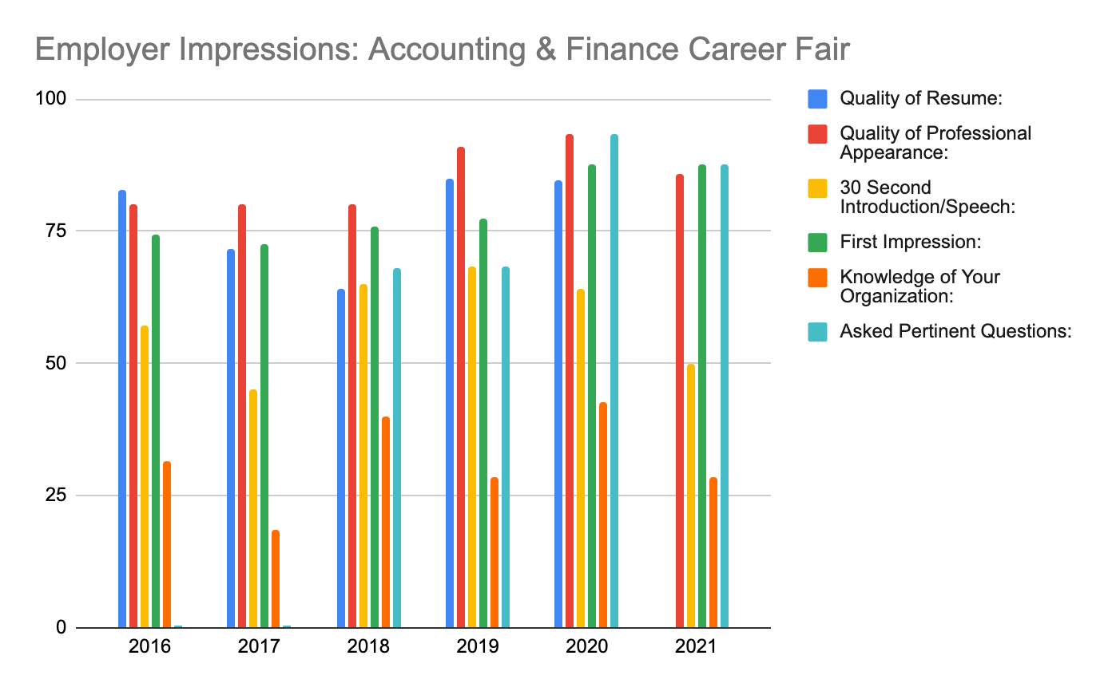

**Results and Action Taken/Explanation/Future Steps**

When asked to rate our students across a variety of metrics, employers rated our students less on all impression values in comparison to 2020, which was disappointing to see. ***Quality of professional appearance, 30-second introduction/pitch, and Asked pertinent questions* all decreased by 7.6%, 14.2%, and 5.8% respectively**. Another drastic decrease was Knowledge of your organization which was down 14.1%. This year was the lowest rating for student’s knowledge of the organization. To alleviate this issue moving forward, we should explore prep events that highlight how to research companies. It is unclear what the decreases may be attributed to but may be related to a decrease in student appointments for the fall semester of 2021. Additionally, the prep session that was held did not have an incredibly high attendance rate with 12 students attending, against 343 registrants. Despite these decreases, there was a 14.2% increase in overall First impression and 87.5% of employers said they were moderately or very likely to work with students whom they met at this event. Because of this, one can infer that the 1:1 sessions still went well and were successful.

Midsize firms that attended the event received slightly less 1:1 sign ups compared to their larger firm counterparts. Midsize firms may need additional spotlight well in advance of the fair for students to familiarize themselves and begin their research. For example, BKD hosted a virtual career fair prep workshop 2 days prior to the event. 12 students attended the workshop and BKD had 17/27 1:1 slots filled. An idea moving forward could be to hold various workshops in the week preceding the event that are related to career fair readiness and each workshop can be sponsored by a different midsize firm. This can also be an idea to further generate revenue, or can be voluntary.

The Employer Relations team once again offered an Employer Support Zoom Room where struggling employers could come for assistance, technical help or other related issues. This room was not visited by any employers due to all tech related systems cooperating. The team also compiled a list of common user issues with troubleshooting links, as well as the Handshake hotline. We were fortunate enough to have no tech related issues this go around, which again can be attributed to comfortability navigating the virtual space.

Overall, this event was successful in the virtual space. Employers have shared that virtual fairs are a preferred method of engagement so with the uncertainty of the future, it is great to know that this method works.

**EVENTS, APPOINTMENTS & JOB POSTINGS**

|  |  |  |  |  |  |  |
| --- | --- | --- | --- | --- | --- | --- |
| **EVENTS BY MONTH** | RH Events | LC Events | Events Total | RH Students | LC Students | Students Total |
| **August** | 7 | 7 | 14 | 34 | 12 | 46 |
| **September** | 25 | 17 | 42 | 264 | 22 | 286 |
| **October** | 44 | 18 | 62 | 216 | 40 | 256 |
| **November** | 8 | 7 | 15 | 23 | 6 | 29 |
| **December** | 13 | 3 | 16 | 111 | 13 | 124 |

|  |  |  |
| --- | --- | --- |
| **MONTHS** | Appointments Total | All Jobs Posted and Expired |
| **August** | 127 | 8216 |
| **September** | 325 | 10057 |
| **October** | 387 | 9963 |
| **November** | 289 | 9435 |
| **December** | 178 | 27,866 |

Notes: August has no in-person appointments (semester has not started yet). As usual, events in RH have more students than events in LC, even virtually. This holds true for all 5 months in the Fall 2021 semester. Events and appointments peak in September and October, and they decline in November and December due to Thanksgiving and Winter break. The spike in jobs posted and expired in the month of December is an outlier

**INDEX**

**FIRST DESTINATION SURVEY 2021**

Year on Year Comparisons FDS

November

Year to Year Comparisons

**DATE 11/20/17 11/08/18 11/8/19 11/5/20 11/4/21**

Knowledge Rate : **94.7**%, **93.4%**  **92% 77.9% 85.0%**

Employed FT : 51% 55% 55.4% 44% 59.57%

Continuing Education: 18% 20% 20% 25% 22.92%

Still Looking: 17% 19% 15.6% 24% 14.9%

Not seeking: 3% 3% 3.4% 1% 0.9%

**As of 11/4/2021**, our first destination outcomes are **85%** knowledge rate, **60%** secured full time employment, **23%** continuing education and **15%** seeking employment.

Year to Year Comparisons

**DATE 11/20/17 11/15/18 11/14/19 11/11/2020 11/11/2021**

Knowledge Rate **94.7**%, **93.6:%**  **92.1**%  **79.6% 85.10%**

Employed FT: 51% 57% 56% 46% 60%

Continuing Education: 18% 20% 20% 23% 23%

Still Looking: 17% 17% 15.1% 22% 14.23%

Not seeking: 3% 3% 3.4% 0.8% 0.90%

As of **11/11/2021** our first destination outcomes are **60%** knowledge rate, 46**%** secured full time employment, **23%** continuing education, **0.9%** not seeking and **14.23%** seeking employment.

Year to Year Comparisons

**DATE 11/20/17 11/20/18 11/20/2020 11/18/21**

Knowledge Rate : **94.7**%,  **93.6:%**  **80.2% 85.7%**

Employed FT : 51% 57% 45% 61%

Continuing Education:18% 20% 24% 23%

Still Looking: 17% 17% 22% 14%

Not seeking: 3% 3% 1% 0.92%

As of **11/18/21**, our FDS outcomes are **85.7%** knowledge rate, **61%** secured full-time employment, **23%** continuing education, **0.92%** not seeking, and **14%** still seeking employment

Key indicators including knowledge rate, and those still seeking employment have visibly improved from 2020, and even 2018. Lower percentage of people not seeking employment as well. Entirely possible that the lower rate of those “still looking” or “not seeking” is because of lower knowledge rate from 2020 to 2021.

Year-To-Year Comparisons

**DATE 12/01/17 12/06/18 12/04/19 12/3/2020 12/2/2021**

Knowledge Rate : **96.3**%, **95%**  **93% 81.3% 86.7%**

Employed FT : 52.9% 58% 56.47% 45% 61%

Continuing Education: 17.3% 20% 20.4% 24% 23%

Still Looking: 16% 15% 14.4% 21.9% 14%

Not seeking: 3% 3% 3.6% 0.8% 0.92%

*Note that this is a combination of Late November and Early December FDS tracking, although the numbers have not changed very much due to Thanksgiving Break.

Note that all metrics are more positive than in 2020, but it still trails behind pre-pandemic years. Knowledge Rate still hovers around 86%, students are not responding as much as they used to. Full-time employment is on the recovery at 53%, we will see if this trend continues through next year. Continuing Education and “Still Looking” remain about the same. Those not seeking employment has also remained the same since 2020, but there is a noticeable decrease in alumni not seeking employment after 2020.

Year-To-Year Comparisons

**DATE 12/17/17 12/13/18 12/12/19 12/11/20 12/9/21**

Knowledge Rate : 96.7%, 95.2% 94% 81.4% 87.30%

Employed : 55% 60% 57% 45% 62.21% Continuing Education: 18% 20% 20% 24% 22.81%

Still Looking: 14% 14% 14% 21% 12.37%

Not seeking: 3% 3% 4% 1% 1.12%

Year-To-Year Comparisons

**DATE 12/17/17 12/19/18 12/19/19 12/17/20 12/15/21**

Knowledge Rate  **96.7**%,  **95.8% 94% 81.5% 87.3%**

Employed 55% 61% 58.5% 53% 62.31%

Continuing Education: 18% 20% 20% 24% 22.81%

Still Looking: 14% 13% 12% 21% 12.26%

Not seeking: 3% 3% 4% 1% 1.12%

**Resources**

<https://docs.google.com/document/d/1MI8tbbPDFBc-mLD7sdyT45NJLPHzTRkYmc27SAJBhCU/edit?usp=sharing>

2021 Workbook: <https://onedrive.live.com/edit.aspx?cid=480c5a40f2c8aa97&page=view&resid=480C5A40F2C8AA97!107&parId=480C5A40F2C8AA97!106&app=Excel>

FDS Weekly Data: <https://onedrive.live.com/edit.aspx?cid=480c5a40f2c8aa97&page=view&resid=480C5A40F2C8AA97!112&parId=480C5A40F2C8AA97!106&app=Excel>

2020 Weekly utilization reports for reference (FDS): <https://docs.google.com/document/d/1Vuv2OKE85feBNvaVosGakawRV-Lr0sgnfQYmbZQ9D08/edit>

Fall 2021 Accounting and Career Fair Report Data (Students and Employers are separate):

<https://drive.google.com/drive/folders/1bgJUigpXYpY2F0YTgh8REH34BeQ7vn-w>

Fall 2021 Tech Expo Report Data (Students and Employers are separate):

<https://drive.google.com/drive/folders/16wzDm99WWSIGOcQxOJPq9PkTRLgDNAjR>